**Simulating Olson's Bandits: An ABM Exploration of Government Decision Dynamics**

Chasen Jeffries 1

1School of Social Science, Policy & Evaluation, Claremont Graduate University, Claremont California, United States of America

chasen.jeffries@cgu.edu

**Abstract.** This study extends Mancur Olson's seminal work on the role of roving and stationary bandits in shaping governance and economic performance, employing agent-based simulations to explore the dynamics between rulers and their subjects. By simulating Olson’s concepts within complex adaptive systems, our research reveals that rational roving bandits, when faced with varying environments and tax rates, strategically transition to stationary bandits to optimize their fitness function, thereby establishing peace and order but not necessarily providing other public goods. This finding introduces a new equilibrium for autocrats, challenging Olson's assumption that the provision of a broader spectrum of public goods is necessary for societal thriving. The simulations underscore that while roving-stationary bandits can survive by adopting low-tax strategies, stationary bandits that invest in their subjects and provide additional public goods emerge as the fittest agents, aligning with Olson’s theory on the evolution of governance from banditry to established governments. This illuminates the complexities of how varying bandit characteristics and operational context impact government formation and decision-making.

**Keywords:** Agent-Based Modeling (ABM), Olson’s Bandits, Complex Adaptive System, Co-Evolution, Governance

1. Introduction

In 1993, Mancur Olson published a paper exploring how bandits could explain variations in governance and economic performance outcomes. Olson posited that roving and stationary bandits are rational agents trying to maximize their gains. He demonstrated how their endowed characteristics and operational context simultaneously reveal the formation of governments and the nature of their decisions. These heterogenous bandits dynamically adapt within complex adaptive systems and co-evolve with their subjects to maximize their fitness function. Over the ensuing decades, scholars have extensively critiqued and engaged in debates spurred by this theory, focusing on the origins and fundamental elements influencing governance.

Building upon Olson’s foundational work, subsequent researchers (McGuire et al. 1996, Young 2016, Piano 2019) have further developed the initial theory. These scholarly contributions aim to more precisely articulate the dynamics between rulers and the ruled, as well as the evolution from banditry to established governance and the provisioning of public goods. In 1997, Banks, Olson, and Porter developed an experimental model to investigate how agents' decision-making processes vary with their time horizons and levels of risk aversion.

We extend the established literature by simulating Olson’s concepts of roving and stationary bandits, aiming to assess whether theoretical predictions align with our simulation outcomes. In our simulations, roving and stationary bandits compete within a dynamic environment, allowing us to examine the co-evolution of heterogeneous bandit decision-making with their subjects and its impact on macroeconomic outcomes. Our model incorporates a complex adaptive system that facilitates feedback mechanisms, enabling the bandits and subjects to dynamically evolve in pursuit of optimizing their strategic outcomes. This model represents an initial effort to rigorously evaluate Olson's core principles, particularly focusing on the effects of government-subject relationships and government decision-making processes on economic performance.

This research offers significant practical implications, as our simulations underscore the profound impact of government-subject dynamics and decision-making processes on economic outcomes, suggesting avenues for policy intervention and governance reform. Moreover, our model delineates specific scenarios and conditions under which governments emerge and evolve, offering insights into the transition points at which roving bandits opt to become stationary, thus stabilizing their governance.

This model represents a pioneering effort to simulate the dynamic co-evolution of rulers and ruled, aiming to unravel the complexities of ruler decision-making and its impact on the economic performance of both governments and subjects. Central to our model is Olson’s insight that rational roving bandits may elect to become stationary to optimize their fitness function, engendering a symbiotic co-evolution with their subjects. Furthermore, our simulations explore how foundational government decisions, such as taxation and investment, influenced by local environmental dynamics, result in varied outcomes across generations. However, this model does not address the potential transition to democracy or the problematic tendencies inherent in autocratic successions.

1. Related Work
2. Olson’s bandits and government-subject dynamics

In his 1993 theory, Olson posited that within a competitive landscape of roving bandits, rational actors would opt to become stationary bandits, recognizing the potential for greater wealth accumulation as autocrats compared to the transient gains from roving banditry. Stationary bandits impose lower taxes than their roving counterparts and establish a peace and order, as well as contributing to the provision of public goods. This arrangement incentivizes subjects to invest in the future, promising them greater long-term rewards under a new equilibrium where both parties benefit from a symbiotic relationship. Thus, Olson's theory offers a pivotal explanation for government formation, addressing and overcoming the fundamental issue of collective action problems, and governance impact on economic development.

Following Olson’s seminal postulation, numerous scholars have expanded upon his theoretical framework (Young 2016, Kurrild-Klitgaard et al. 2003), delving into the nuanced decision-making of rulers and their balancing act between extracting resources from society and providing public goods (McGuire et al. 1996, Kirstein et al. 2006, Piano 2019). Alternatively, Moselle and Polak (2001) present a critical viewpoint, arguing that the provision of public goods by rulers, while potentially enhancing economic performance, may not necessarily translate to better outcomes for subjects. While these models elucidate theoretical principles, they often fall short in empirical testing. Addressing this gap, Banks, Olson, and Porter (1997) developed an experimental model to investigate the decision making postulated by Olson, offering empirical support to his theoretical assertions. While this model tests key elements of Olson's theory, our research goes a step further by rigorously examining the intricate dynamics between rulers and subjects within a constantly evolving landscape of roving and stationary bandits.

1. Simulations dyadic decision making in evolving landscapes

Recent decades have witnessed a significant paradigm shift in social sciences through the proliferation of agent-based simulations, facilitating bottom-up analyses. The 1996 release of “Growing Artificial Societies” by Epstein & Axtell showcased the profound potential of simple, iteratively modified models to yield insightful and paradigm-shifting results. In their simulation, heterogeneous agents, with distinct endowments of skill and resources engage, in competition within a dynamic landscape to secure resources. This model laid significant groundwork for employing agent-based modeling in simulating complex social science processes, opening new avenues for research and theory development.

Researchers have utilized this technique to model key scenarios and theories, contributing to empirical research by creating heterogeneous agents endowed with specific capabilities and initial conditions, which adapt within a dynamic, uncertain landscape to maximize their fitness functions (Axtell et al. 2002, Schelling 1971, Vriend 2007). The Wolf-Sheep predation model, significantly explored in studies by Wilensky et al. (1998, 2006), Marucco et al. (2010), and Husnain (2021), simulates the evolution of population dynamics based on simple decision-making within a dynamic landscape, offering insights into the dynamic co-evolution of species and the sensitive dependence on initial conditions.

The foundational simulations in the field provide a rich background that underpins our simulation efforts. Our bandit-subject relationship's population dynamics parellel those observed in the wolf-sheep predation model. We also adopt Epstein and Axtell’s simple observation and decision-making rules to construct the decision tree for our roving bandits. Lastly, by incorporating Olson’s core decision-making dynamics through a simplified set of rules and equations, we effectively simulate the evolving landscape and the behavior of self-maximizing bandits as theorized by Olson.

1. Modeling Olsons Bandits

Figure 1 presents a detailed overview of the capabilities and decision-making methods of our heterogeneous bandits, highlighting their distinct strategies. Although both types of bandits possess the ability to tax their subjects, they are distinguished by unique capabilities that allow for a broad exploration of behaviors. Roving bandits, represented in blue, utilize a decision tree to strategically determine their movements. In contrast, stationary bandits, depicted in red, can invest in their territories to offer public goods beyond mere peace, enhancing the well-being of their subjects.

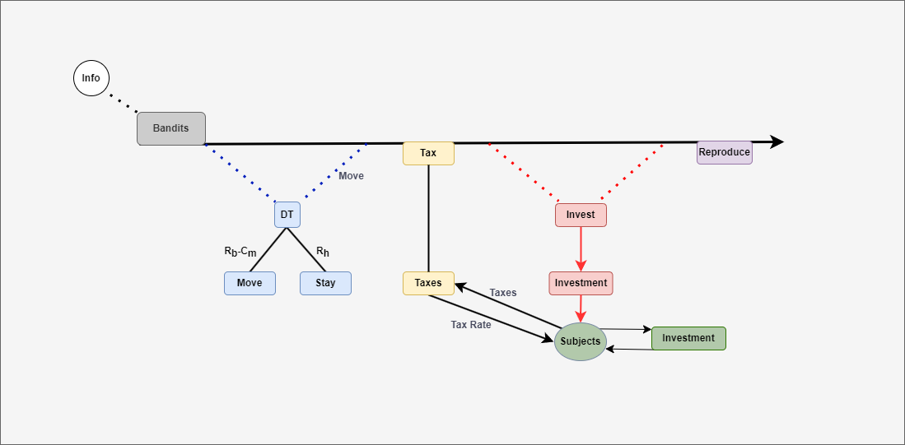**Figure 1: Bandit Decision Making Model**

Initially, both types of bandits assess the local environment, gathering information on available resources to inform their strategies. Utilizing this information, roving bandits determine the optimal location for their next move, integrating this into their decision tree. The best location is characterized by the most abundant resources and the absence of stationary bandit control. Having assessed the optimal move and its associated costs, roving bandits consult their decision tree to choose between moving or remaining at their current position. Should multiple roving bandits converge on the same location, a conflict ensues, resulting in all but one bandit fleeing to a randomly selected nearby space.

Following the conclusion of all movements, both roving and stationary bandits levy taxes on their subjects at predetermined rates, subsequently collecting the resulting income. The imposed tax rate directly influences the subjects’ investment rate, dictating the proportion of their resources they allocate to development. In this model, the subjects’ investment rate inversely correlates with rate at which they are taxed, reflecting the delicate balance that stationary bandits must navigate between taxation and potential returns on investment. Rooted in Olson’s core assumption, our model posits that subjects are motivated to invest in their domains primarily when they are assured a share of the investment's returns. Subjects’ investment rates are calculated using the following equation:

$I_{s}=1-T_{b}-0.4$ (1)

Is represents the investment rate of the subject, and Tb denotes the tax rate imposed by the bandit. We establish a base saving rate of 0.4, representing the minimum threshold that subjects must achieve before considering future investments. In scenarios where taxation is absent, the investment rate gradually increases, reflecting the subjects’ growing optimism about future prospects. Thus, the interplay between the base rate and taxation critically influences the subjects’ willingness to invest.

Subsequently, stationary bandits invest in their subjects. This action embodies Olson's fundamental assumption: for society to thrive, governments must ensure peace, property rights, and contract enforcement. Although our published results utilize a simple interest equation, the model is also compatible with compound and exponential interest calculations. The simple interest calculation involves the bandits' investment amount (Ib), their investment time horizon (Hb), and an assumed interest rate of 0.05.

$Y=I_{b}*r*H_{b}$ (2)

Once stationary bandits have invested in their subjects, they are precluded from making further investments until the initial investment has matured. Subjects have the ability to invest in themselves by applying their investment rate, as determined by Equation 1, to the simple interest formula.

At the end of each tick in the simulation, bandits undergo base attrition, reflecting the necessity to sustain themselves to avoid extinction. Wealthy bandits, having sufficiently accumulated resources, possess the ability to reproduce, thereby generating new bandits of their respective type—either roving or stationary.

1. Results
2. Baseline

To begin, we establish a benchmark to gauge the baseline performance of bandits within the simulation, serving as a foundational comparison point for assessing outcomes across various scenarios. Table 1 outlines the values of key variables, including bandits' operational parameters and subjects' behavioral tendencies, essential for understanding the simulation dynamics. Normal distributions are applied to model variables such as the bandits' observation range, tax rate, investment rate, investment time, and the subjects' optimism, ensuring variation in these parameters. This approach creates a dynamic and realistic simulation landscape, presenting bandits and subjects with a nuanced environment characterized by variable costs and opportunities.

| Parameters | Description | Base value |
| --- | --- | --- |
| Population | Total number of bandits | 50 |
| Stationary Population | The initial number of stationary bandits | 25 |
| Observation Range | How far the bandits can see around them (mean & standard deviation) | 3:1.5 |
| Move Cost | The cost for bandits to move one step. | 2 |
| Spawn Rate | The rate new bandits spawn from the fit bandits | 1 |
| Attrition Rate | The rate at wish bandit loses wealth each tick | 0.25 |
| Tax Rate | The bandits tax rate for their subjects | 0.4:0.2 |
| Investment Rate | The Stationary Bandit investment rate into their subjects | 0.25:0.125 |
| Investment Time | The Stationary Bandit time of investments | 1.5:0.75 |
| Optimism | The optimism of subjects that the future will get better. | 0.025:0.012 |

**Table 1: Baseline initial conditions and parameter values**

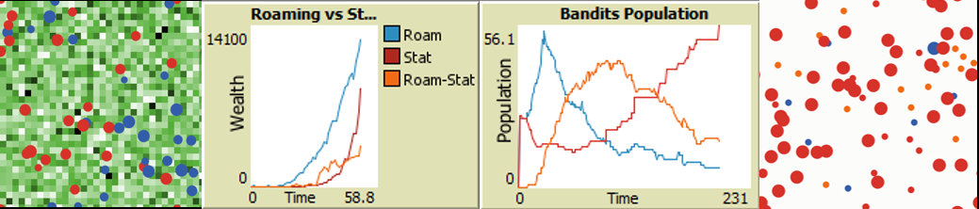**Figure 1: Baseline environment, time series wealth and population plots**

In the baseline scenario, roving bandits initially outperform stationary bandits, swiftly accumulating resources and expanding in population as illustrated by the first 25 ticks on the time series wealth plot. However, this dominance is short-lived; stationary bandits gradually surpass roving bandits as their investments mature. The intensifying competition among roving bandits diminishes their returns significantly, especially as available subjects become scarce and less inclined to invest in themselves due to frequent raids. Consequently, the landscape undergoes a dramatic transformation, from a normal distribution, resource-rich environment to one starkly barren except for the wealth now concentrated within the domains of stationary bandits.

Interestingly, the simulation reveals a bifurcation among roving bandits driven by their tax rate, leading to distinct paths in their evolution. Roving bandits that adopt lower tax rates transition to roving-stationary status, signified by turning orange, after remaining immobile for 10 consecutive ticks. These newly stationary bandits often outnumber their roving counterparts and maintain their fitness by assuming a leadership role over their subjects, taxing them minimally without offering public goods. This minimal taxation strategy ensures that their subjects remain incentivized to invest, showcasing how rational bandits sustain their autocratic position without providing public goods, demonstration a new equilibrium strategy. In contrast, true roving bandits, maintaining their nomadic nature, levy nearly maximum taxation rates above 90 percent.

Ultimately, true stationary bandits—those who are both capable and willing to invest in their subjects—outperform both roving bandits and converted stationary bandits. This outcome provides strong empirical support for Olson's theory, illustrating that rational bandits opt for a stationary lifestyle and, by investing in their subjects, achieve superior long-term performance compared to their counterparts.

1. Scenario 1: Resource Rich

In this scenario, we introduce our bandits to a resource-rich environment. The primary objective is to examine the evolution of roving bandits' decision-making processes in response to an environment abundant in resources from the outset. Additionally, this scenario investigates whether a higher resource starting environment empowers stationary bandits to further dominate the landscape and outperform their roving counterparts.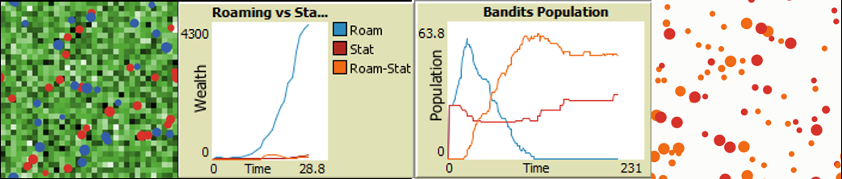  
**Figure 2: Scenario 1 environment, time series wealth and population plots**

The bandit population time series plot reveals that roving bandits almost invariably face extinction. Further investigation reveals a significant population explosion among roving bandits, exacerbating the competition for resources. This intense competition for an initially abundant resource pool rapidly depletes the landscape, precipitating a population collapse reminiscent of dynamics observed in Wolf-Sheep predation models.

Roving bandits that strategically transition to stationary status often become the most populous agents. This suggests that, in the medium term, transitioning roving bandits capture more resources and exhibit superior fitness, resulting in faster population growth compared to original stationary bandits. Both transitioning roving bandits and original stationary bandits reach an equilibrium stabilizing of their populations. Despite population stability, original stationary bandits maintain a long-term advantage over their transitioning counterparts, attributed to their investments in public goods that bolster the economic performance of their subjects.

1. Scenario 2: Resource Rich, Low Taxes

Expanding on scenario one's resource-rich landscape, this evolution introduces lower tax rates for bandits, now ranging from 0 to 0.4, a reduction from the original range of 0 to 0.8. This adjustment aims to more precisely assess the tax rate's influence on both roving and stationary bandits' strategies and outcomes. The key questions are whether lower tax rates disproportionately impact roving bandits over stationary ones, and if such rates enable roving bandits to secure gains without deterring subjects' investments—thereby maintaining a fertile landscape and averting the population bubble and collapse observed previously.

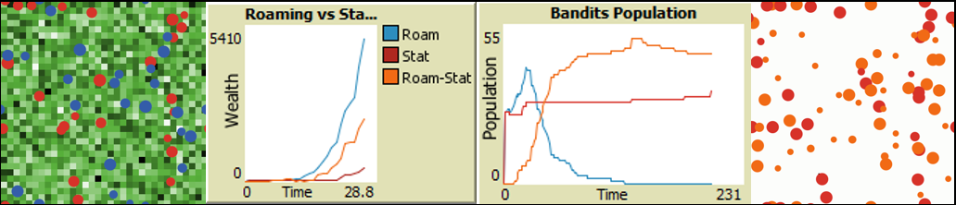  
**Figure 3: Scenario 2 environment, time series wealth and population plots**

Roving bandits face rapid decline; however, the majority transition to stationary status, adopting it as the dominant strategy for survival. his adaptation underscores an equilibrium where low tax rates enable former roving bandits to not only survive but thrive, effectively becoming successful roving-stationary bandits.

Stationary bandits that invest in their subjects maintain the upper hand in the model, excelling in resource capture through their strategic investments. The mutual benefits arising from bandits' investments and subjects' self-investment create a symbiotic relationship, enabling both parties to thrive. Roving-Stationary bandits adopt a nuanced strategy, levying lower taxes to incentivize subjects' self-investment, thereby benefiting from a more *laissez-faire* approach.

1. Scenario 3: Resource Rich, High Taxes

Scenario 3 explores the impact of high taxes on governance decision-making, contrasting with Scenario 2's focus on low taxes. This scenario aims to further unravel the dynamic equilibria among roving, roving-stationary, and stationary bandits, dictated by their differing tax strategies. Here bandits are given high tax rates ranging from 0.2 to 1, a significant increase from Scenario 2's 0 to 0.5 range and the baseline's 0 to 0.8.

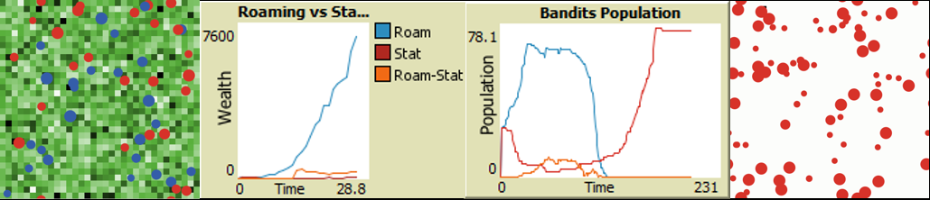  
**Figure 4: Scenario 3 environment, time series wealth and population plots**

Stationary bandits subject to high tax rates face rapid extinction, while those imposing low to medium tax rates not only survive but flourish. Likewise, roving-stationary bandits only survive under low tax rates, mirroring the survival condition of their stationary counterparts.

Initially, roving bandits seem to adopt the dominant strategy, with very few opting to transition into a roving-stationary status. The roving bandits' population experiences growth, stabilizes for a brief period, and then undergoes a sudden collapse. Ultimately, this scenario proves unsustainable for roving bandits, leading to their complete extinction.

1. Conclusion

Despite being an initial exploration of Olson's bandits with a relatively simple ruleset, our simulation yields significant conclusions. Firstly, rational roving bandits strategically adapt to their environments by transitioning into stationary bandits. Secondly, despite their adaptation, these roving-stationary bandits abstain from providing public goods or making investments in their subjects. This reveals a previously unidentified equilibrium for autocrats, challenging Olson's assumption that societal thriving requires governments to provide peace alongside other public goods. Thirdly, although roving-stationary bandits find a niche to survive and flourish, stationary bandits offering additional public goods emerge as the model's fittest agents, in alignment with Olson's theory.

Future models can build on these foundations and enhance alignment with Olson's theory by incorporating learning mechanics that enable bandits to adapt, optimizing their tax and investment rates to maximize fitness. Moreover, future simulations could equip bandits with sophisticated decision-making tools to actively determine their time horizons and better predict future outcomes. Lastly, the model could adjust subjects' optimism or time horizons based on bandit behavior; frequent changes might increase uncertainty and shorten time horizons, whereas consistency extends them.

This study offers significant insights into the formation of governments. Understanding these dynamics is crucial for analyzing how initial communities overcome the collective action problem and the pathways through which nation-states in civil strife might evolve into a government. A deeper comprehension of the intricate dynamic between rulers and ruled enhances our ability to explain and predict significant deviations in government decision-making and their economic consequences.

1. References:

Axtell, R. L., Epstein, J. M., Dean, J. S., Gumerman, G. J., Swedlund, A. C., Harburger, J., Chakravarty, S., Hammond, R., Parker, J., & Parker, M. (2002). Population growth and collapse in a multiagent model of the Kayenta Anasazi in Long House Valley. Proceedings of the National Academy of Sciences, 99(suppl_3), 7275-7279. https://doi.org/10.1073/pnas.092080799

Banks, J., Olson, M., & Porter, D. (1997). An Experimental Analysis of the Bandit Problem. Economic Theory, 10(1), 55–77. http://www.jstor.org/stable/25055024

Bó, E. D., Hernández, P., & Mazzuca, S. (2015). The paradox of civilization: Pre-institutional sources of security and prosperity. NBER Working Paper. http://www.nber.org/papers/w21829.

Epstein, J. M., & Axtell, R. (1996). Growing Artificial Societies: Social Science from the Bottom Up. Brookings Institution Press.

Höijer, R. (2004), Theft by Bandits and Taxation by Kings: A Critique of Mancur Olson on State-Formation. Political Studies Review, 2: 24-38. https://doi.org/10.1111/j.1478-9299.2004.00002.x

Husnain, M., & Shafi, N. (2021). An extension to wolf sheep predation (docked hybrid) agent-based model in NetLogo. Journal of Software Engineering & Intelligent Systems, 6(1).

Kirstein, R., & Voigt, S. (2006). The Violent and the Weak: When Dictators Care about Social Contracts. The American Journal of Economics and Sociology, 65(4), 863–890. http://www.jstor.org/stable/27739596

Kurrild-Klitgaard, P., Tinggaard Svendsen, G. Rational Bandits: Plunder, Public Goods, and the Vikings. Public Choice 117, 255–272 (2003). https://doi.org/10.1023/B:PUCH.0000003733.81946.d3

Marucco, F., & Mclntire, E. J. B. (2010). Predicting spatio-temporal recolonization of large carnivore populations and livestock depredation risk: wolves in the Italian Alps. Journal of Applied Ecology, 47(4), 789–798. http://www.jstor.org/stable/40835697

McGuire, M. C., & Olson, M. (1996). The Economics of Autocracy and Majority Rule: The Invisible Hand and the Use of Force. Journal of Economic Literature, 34(1), 72–96. http://www.jstor.org/stable/2729410

Moselle, B., & Polak, B. (2001). A Model of a Predatory State. Journal of Law, Economics, & Organization, 17(1), 1–33. http://www.jstor.org/stable/3554995

Olson, M. (1993). Dictatorship, Democracy, and Development. The American Political Science Review, 87(3), 567–576. https://doi.org/10.2307/2938736

Piano, E. E. (2019). State capacity and public choice: a critical survey. Public Choice, 178(1/2), 289–309. https://www.jstor.org/stable/48703356

Sandler, T., & Tschirhart, J. (1997). Club theory: thirty years later. Public Choice, 93, 335–355.

Wilensky, U. & Reisman, K. (1998). Connected Science: Learning Biology through Constructing and Testing Computational Theories -- an Embodied Modeling Approach. International Journal of Complex Systems, M. 234, pp. 1 - 12.

Wilensky, U., & Reisman, K. (2006). Thinking like a Wolf, a Sheep, or a Firefly: Learning Biology through Constructing and Testing Computational Theories-An Embodied Modeling Approach. Cognition and Instruction, 24(2), 171–209. http://www.jstor.org/stable/27739831

Young, A.T. What does it take for a roving bandit settle down? Theory and an illustrative history of the Visigoths. Public Choice 168, 75–102 (2016). https://doi.org/10.1007/s11127-016-0350-7